Cross Connection/Backflow Prevention
Frequently Asked Questions

1. What is a cross connection?

A cross-connection is any physical or potential connection between a potable water supply and a non-potable water system — in our case, Gardner Community Water Association’s public water lines and our customers’ private plumbing systems. Backflow can occur through cross-connections.

2. What is backflow?

Backflow is simply a reversal of the normal flow of water – from the customer side of the meter into the water system. It can happen as a result of water pressure differences or sudden changes in pressure and can allow contaminants to be pumped or siphoned back into buildings’ plumbing systems, and potentially, the public water supply. These situations occur if normal pressures are interrupted by a water main break, a power failure or some other disruption in water service. There are two types of backflow - back pressure backflow and back siphonage backflow.

3. Why is it important for water suppliers to prevent backflow?

Backflow into a public water system can pollute or contaminate the potable water in that system since backflow can make the water unusable or unsafe to drink. Water suppliers have a responsibility to provide water that is usable and safe to drink under all foreseeable circumstances. Furthermore, consumers generally have absolute faith that water delivered to them through a public water system is always safe to drink. For these reasons, the Gardner Community Water Association must take reasonable precautions to protect its public water system against backflow.

4. What are some examples of cross connections?

• A hose submerged in polluted or contaminated water

• A private well or pump that is directly connected to the potable water supply system

• A heating boiler with treatment chemical added to prevent internal corrosion is connected directly to the water supply for make-up water

• An underground lawn sprinkler system is directly connected to the water supply system

• A fountain or swimming pool has a direct connection with the water system for filling

• A home pressure washer that is directly connected to the potable water supply system

In all these examples, a sudden drop in water pressure could draw contaminants – chemicals, fertilizer, soapy water or even bacteria - back into your pipes and your drinking water supply. Any of these contaminants might be hazardous to your health if ingested.
The best way to prevent this potential contamination is to make sure that you never leave a hose submerged in a tub of water or that you never apply fertilizer to your lawn with a hose-aspirator device. In some cases, such lawn irrigation systems, the cross connection cannot be eliminated and the only means of protection is by installation of an approved backflow prevention device.

5. What is Backpressure Backflow?

Backpressure backflow occurs when the pressure on the customer side of the meter is higher than the supply pressure in a public water system. This situation can be created numerous ways including customer installed pumps, temperature increases in boilers or hot water heaters and elevation differences.

6. What is Back siphonage Backflow?

When there is a sudden reduction in water pressure in the public drinking water distribution system, such as during firefighting or when a water main breaks a suction effect may be created reversing water flow and potentially drawing contaminated water into the drinking water system.

7. What are some commonly used backflow prevention devices?

The type of backflow protection required is based on the degree of hazard that the property represents to the potable water supply. Additional information may be found at http://dhh.louisiana.gov/index.cfm/page/549/n/281. Some common and effective devices installed to prevent backflow are shown below:

Air Gap (AG)
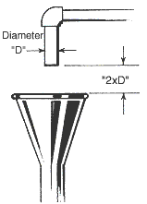

Used mainly on tanks, troughs and sinks, it is a gap between the outlet and the basin. The gap must be a minimum of 2 times the supply pipe diameter.

Pressure Vacuum Breaker (PVB)

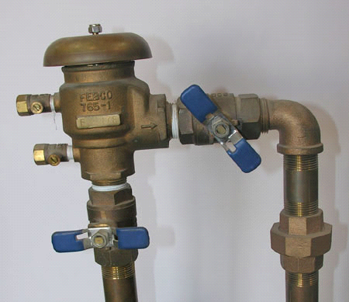

Used mainly on lawn irrigation systems. It has a one-way check and a spring-loaded air inlet valve that closes when water pressure drops.

Atmospheric Vacuum Breaker (AVB)

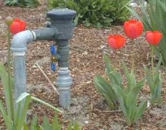

An AVB is a non-testable mechanical backflow preventer with a gravity opening poppet air opening, designed to admit atmosphere into the downstream sides of the unit under a no flow condition to prevent back siphonage. This device is manufacturer installed on certain equipment that uses potable water such as dishwashers and soap dispensers.

Reduced Pressure Zone (RPZ) Assemblies
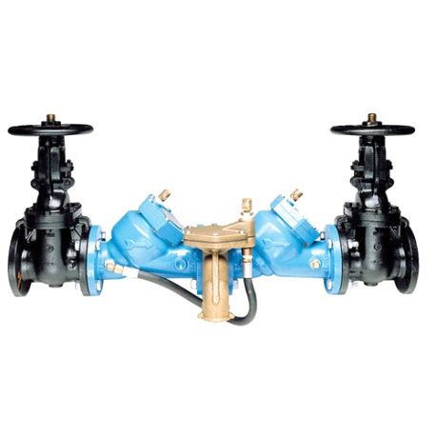
A reduced pressure zone assembly is a mechanical valve assembly that consists of two internally loaded independently operating check valves and a mechanically independent, hydraulically dependent relief valve located between the check valves.

It is used for services that have either health hazards or non-health hazards and under conditions of backpressure or back siphonage. It provides the highest level of protection among the mechanical backflow prevention devices.

8. How do I know if I need a backflow prevention assembly?

A trained employee of the Gardner Community Water Association will visit your property to perform a premise survey for backflow requirements after you have completed the survey mailed to you. You will receive a letter providing you with guidelines and what action you need to take to ensure compliance with Gardner Community Water Association requirements.

9. Is there a general compliance schedule and process?

Yes, your backflow prevention assembly must be in compliance with the Department's testing requirements by the date shown on the notification letter. You will receive a follow up notice after 30 days. After 60 days (if compliance has not already been achieved), you will receive a notice informing you that your water service may be discontinued unless you achieve compliance.

10. Who can install a backflow prevention assembly?

The Gardner Community Water Association recognizes only Backflow Prevention Technicians who are trained and licensed through a Louisiana Department of Health and Hospitals (LADHH) approved training program. Trained and licensed technicians are certified to install and perform annual testing and maintenance of backflow prevention assemblies. A list of State approved testers is available at http://ldh.la.gov/assets/oph/Center-EH/engineering/CCC/LA_Approved_General_Testers.pdf and the Gardner Community Water Association office.

11. Where should a backflow prevention assembly be located?

Backflow prevention assemblies must be located on the customer's side of the water meter and installed in accordance with both the State Plumbing Code and manufacturer specifications. It must be located such that inspection and maintenance can be conveniently performed.

12. Who owns and is responsible for testing and maintenance of the backflow prevention assembly?

The customer is responsible for ensuring that a Certified Backflow Prevention Technician tests, certifies and maintains the backflow prevention assembly. The Gardner Community Water Association will send a notification letter to each customer, advising when testing is due. The customer must contact a Certified Backflow Prevention Technician to perform the test and ensure that a Test and Maintenance Report is received by the Gardner Community Water Association. The customer is responsible for having repair and maintenance on the backflow prevention assembly completed by a Certified Backflow Prevention Technician. After any repair or maintenance, the assembly must be re-tested immediately, and test results submitted to the Gardner Community Water Association.

13. How do I find an approved backflow prevention technician?

A listing of Certified Backflow Prevention Technicians can be found on the LA DHH website, http://ldh.la.gov/assets/oph/Center-EH/engineering/CCC/LA_Approved_General_Testers.pdf. You may also contact the Gardner Community Water Association at (318) 793-4568 for a list of approved technicians. Since prices vary, you may want to contact several Certified Backflow Prevention Technicians to obtain quotes for the installation, maintenance and testing of your assembly.

14. How often do I need to have my backflow prevention assembly tested?

The Gardner Community Water Association requires that you test your Backflow Prevention Assembly at the following times:

1. When your backflow prevention assembly is first installed. Your Certified Backflow Prevention Technician must perform this test.

2. The backflow prevention assembly must be tested annually thereafter. Your Certified Backflow Prevention Technician must perform this test.

3. After any repair or replacement of the Backflow Prevention Assembly. Your Certified Backflow Prevention Technician must perform this test.

15. Why does a backflow prevention device have to be tested annually?

Mechanical backflow preventers have internal seals, springs, and moving parts that are subject to fouling, wear, or fatigue. Also, mechanical backflow preventers and air gaps can be bypassed. Therefore, all mechanical backflow preventers must be tested periodically to ensure that they are functioning properly. A visual check of air gaps is sufficient, but mechanical backflow preventers must be tested by a State Certified Tester, with properly calibrated equipment.

16. Who is responsible for obtaining all required permits?

The customer is responsible for making sure that the Certified Backflow Prevention Technician obtains all required permits from the plumbing code officials responsible for the location. The customer must submit a copy of Assembly Certification to the Gardner Community Water Association after replacement of a backflow prevention assembly.

17. Who do I contact if I have questions about backflow prevention?

Contact the Gardner Community Water Association Office

Sonya Hill
Phone 318-793-4568
405 Mudge Road
Boyce, LA 71409

